Kubernetes Task -05

Task Title
Kubernetes Namespace Resource Management and Service Communication
Objective
• Create and manage multiple namespaces
• Apply ResourceQuota to restrict resource usage
• Configure LimitRange to enforce default, minimum, and maximum constraints
• Deploy pods with defined CPU and memory requests/limits
• Expose applications using NodePort service
• Enable cross-namespace communication using Service DNS
• Validate resource policies through enforcement testing

Prerequisites
• Running Kubernetes cluster
• kubectl configured and connected to cluster
• Administrative access to create namespaces
• Basic understanding of Kubernetes objects (Pod, Service, ResourceQuota, LimitRange)
• Network access to worker nodes (for NodePort validation if needed)

Conclusion
Successfully demonstrated Kubernetes resource governance and service discovery mechanisms by:
• Creating isolated namespaces for different environments
• Restricting resource consumption using ResourceQuota
• Enforcing resource standards using LimitRange
• Deploying pods with explicit CPU and memory constraints
• Exposing workloads via NodePort service
• Validating internal communication using Kubernetes Service DNS
• Verifying Kubernetes policy enforcement through controlled test scenarios

- Create a namespace dev-environment and apply a resource-based quota that restricts the number of pods to 3 and services to 2.
Steps Performed
Namespace Verification
• Checked existing namespaces
kubectl get namespaces
Namespace Creation
• Created a new namespace named dev-environment
kubectl create namespace dev-environment
Namespace Validation
• Verified namespace creation
kubectl get namespaces
Observation:
• dev-environment → Status: Active
ResourceQuota Configuration
• Created ResourceQuota YAML file
vi quota.yaml
• Added quota definition
apiVersion: v1
kind: ResourceQuota
metadata:
name: dev-quota
namespace: dev-environment
spec:
hard:
pods: "3"
services: "2"
ResourceQuota Deployment
• Applied ResourceQuota to namespace
kubectl apply -f quota.yaml
Result:
• ResourceQuota created successfully
Quota Verification
• Checked quota limits
kubectl get quota -n dev-environment
Observation:
• Pods → 0/3
• Services → 0/2
Quota Detailed Inspection
• Described ResourceQuota
kubectl describe quota dev-quota -n dev-environment
Confirmed limits:
• Pods = 3
• Services = 2
Pod Creation Within Quota
• Created pods under quota limits
kubectl run pod1 --image=nginx -n dev-environment
kubectl run pod2 --image=nginx -n dev-environment
kubectl run pod3 --image=nginx -n dev-environment
Result:
• All pods created successfully
Quota Enforcement Testing
• Attempted to create pod exceeding quota
kubectl run pod4 --image=nginx -n dev-environment
Result:
• Request denied by Kubernetes
Error:
exceeded quota: dev-quota
Quota Enforcement Validation
• Re-checked ResourceQuota usage
kubectl describe quota dev-quota -n dev-environment
Observation:
• Pods → 3/3
• Services → 0/2
Validation Steps
• Verified namespace status
• Verified ResourceQuota applied correctly
• Verified pod creation allowed within limits
• Verified Kubernetes blocked resources beyond quota
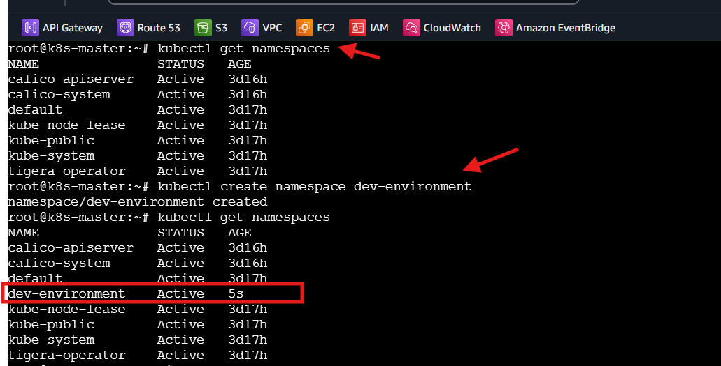
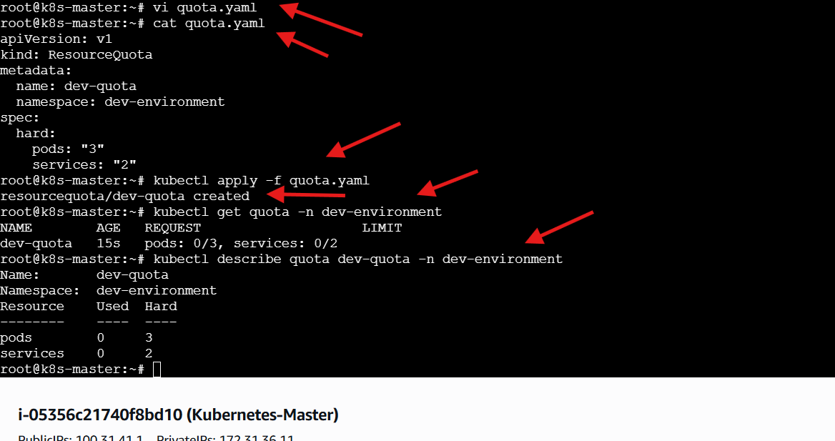
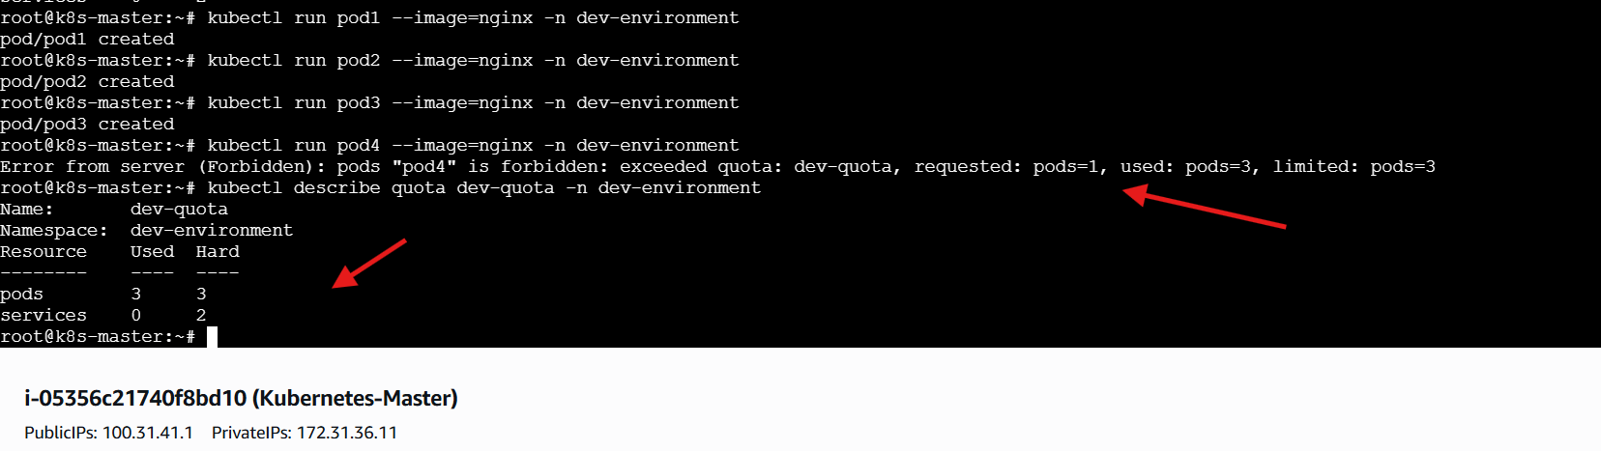

- Create a pod in the prod-environment namespace with 0.2 CPU and 200Mi memory requests, and 0.5 CPU and 500Mi memory limits.

Steps Performed
Namespace Creation
• Created a new namespace named prod-environment
kubectl create namespace prod-environment
Pod YAML Creation
• Created pod definition file
vi prod-pod.yaml
Pod Configuration
• Defined pod with resource requests and limits
apiVersion: v1
kind: Pod
metadata:
name: prod-pod
namespace: prod-environment
spec:
containers:
- name: nginx
image: nginx
resources:
requests:
cpu: "200m"
memory: "200Mi"
limits:
cpu: "500m"
memory: "500Mi"
Pod Deployment
• Applied pod configuration
kubectl apply -f prod-pod.yaml
Result:
• Pod created successfully
Pod Verification
• Checked pod status
kubectl get pods -n prod-environment
Observation:
• prod-pod → Status: Running
Pod Detailed Inspection
• Described pod to verify resource allocation
kubectl describe pod prod-pod -n prod-environment
Confirmed:
• Requests → CPU: 200m, Memory: 200Mi
• Limits → CPU: 500m, Memory: 500Mi
Validation Steps
• Verified namespace creation
• Verified pod creation
• Verified pod running state
• Verified CPU & Memory requests
• Verified CPU & Memory limits
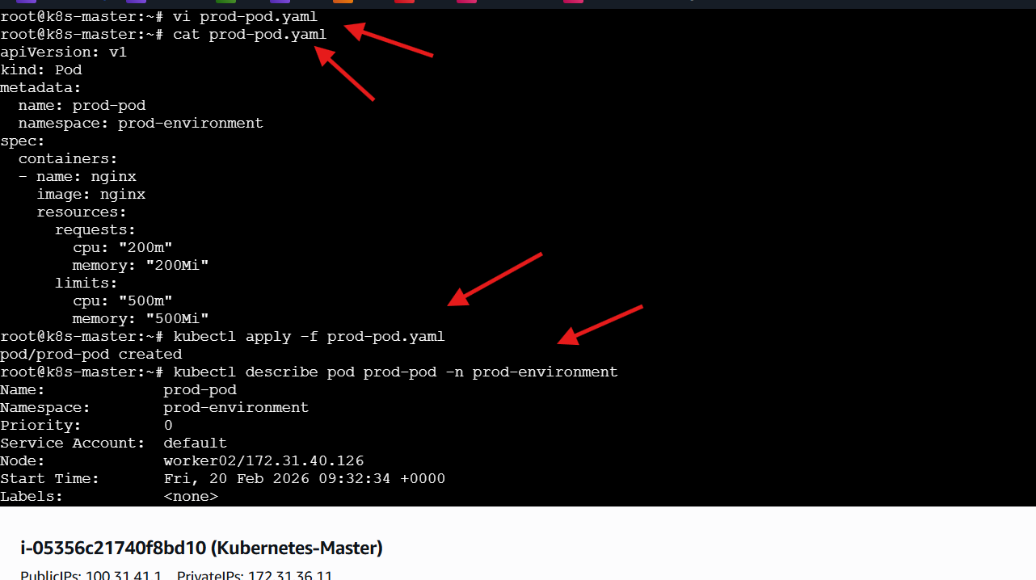
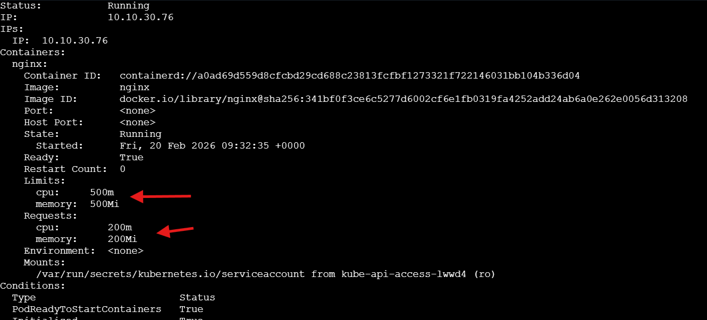

- In the staging-environment namespace, set a LimitRange that assigns default CPU and memory limits (300m CPU, 600Mi memory) and applies a minimum and maximum CPU.

Steps Performed
Namespace Creation
• Created a new namespace named staging-environment
kubectl create namespace staging-environment
LimitRange YAML Creation
• Created LimitRange definition file
vi limitrange.yaml
LimitRange Configuration
• Defined default, minimum, and maximum resource constraints
apiVersion: v1
kind: LimitRange
metadata:
name: staging-limits
namespace: staging-environment
spec:
limits:
- type: Container
default:
cpu: "300m"
memory: "600Mi"
defaultRequest:
cpu: "200m"
memory: "300Mi"
min:
cpu: "100m"
max:
cpu: "1000m"
LimitRange Deployment
• Applied LimitRange configuration
kubectl apply -f limitrange.yaml
Result:
• LimitRange created successfully
LimitRange Verification
• Described LimitRange to inspect applied constraints
kubectl describe limitrange -n staging-environment
Confirmed:
• Default CPU Limit → 300m
• Default Memory Limit → 600Mi
• Default CPU Request → 200m
• Default Memory Request → 300Mi
• Minimum CPU → 100m
• Maximum CPU → 1000m
Validation Steps
• Verified namespace creation
• Verified LimitRange creation
• Verified default resource values
• Verified minimum CPU constraint
• Verified maximum CPU constraint
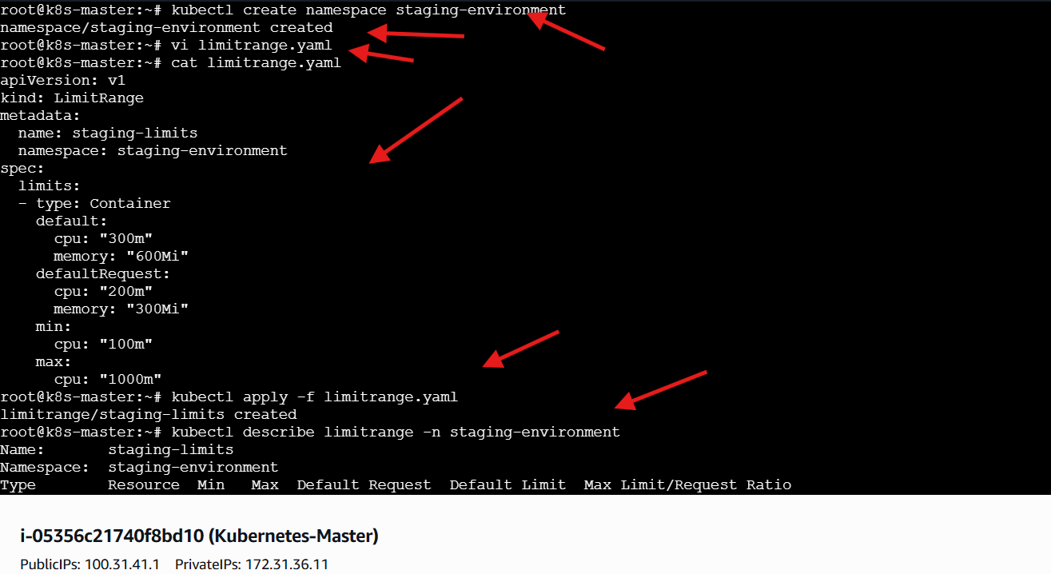
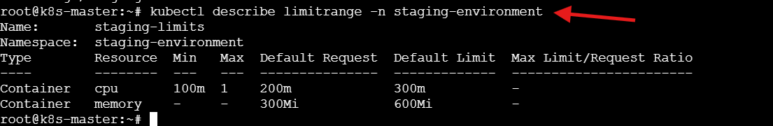
- Create a pod and a Node Port service in the default namespace, then create another pod in the test namespace and communicate between them using Service DNS.

Steps Performed
• Created a pod in the default namespace
kubectl apply -f nginx-pod.yaml
• Verified pod creation
kubectl get pods -n default
Confirmed the pod is in Running state.
• Created a NodePort service to expose the pod
kubectl apply -f nginx-service.yaml

• Verified service creation
kubectl get svc -n default
Confirmed ClusterIP and NodePort assignment.
• Validated service configuration
kubectl describe svc nginx-service
Verified selector, targetPort, NodePort, and Endpoints.
• Launched a temporary debug pod for connectivity testing
kubectl run debug --rm -it --image=busybox -- sh
• Tested service reachability using ClusterIP
wget -qO- <ClusterIP>
Confirmed service routing is functioning.
• Verified pod existence in the test namespace
kubectl get pods -n test
• Entered pod in test namespace
kubectl exec -it nginx-default -n test -- sh
• Tested cross-namespace communication using Service DNS
wget -qO- nginx-service.default
Confirmed Kubernetes DNS resolution and Service discovery.
Validation steps
• Pod successfully deployed
• NodePort service successfully created
• Service selector correctly matched
• Service endpoints verified
• ClusterIP reachable
• Cross-namespace communication via Service DNS successful
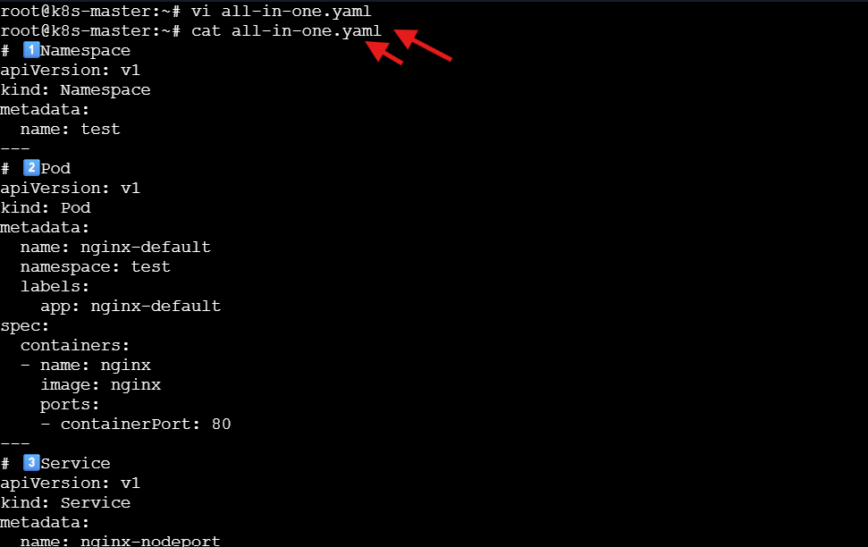
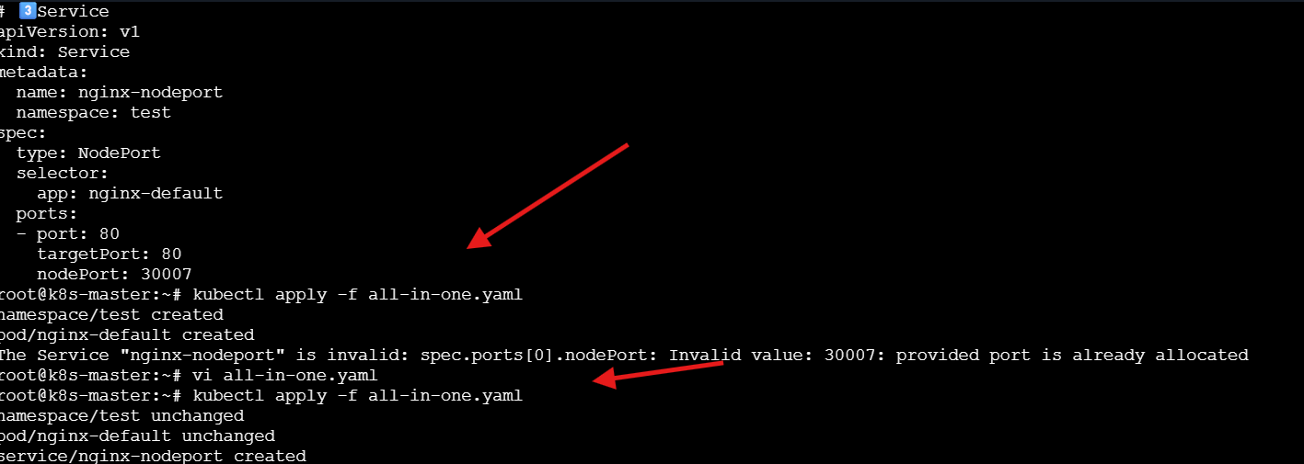
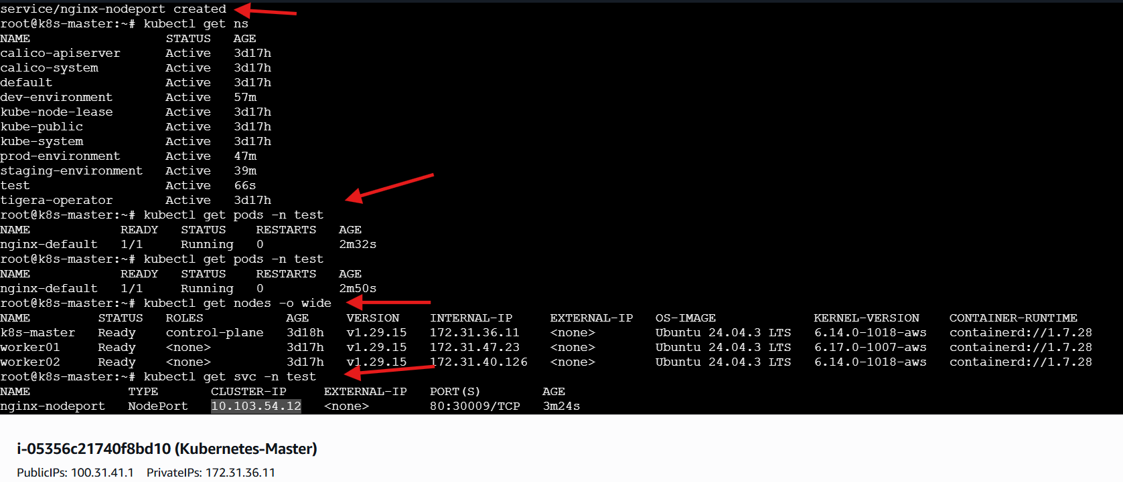
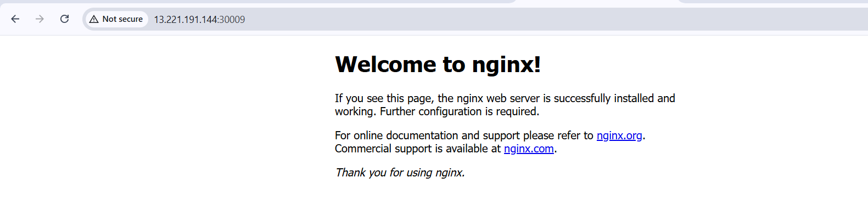

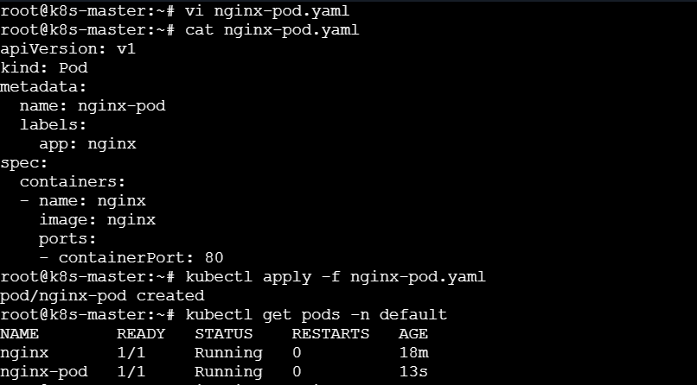
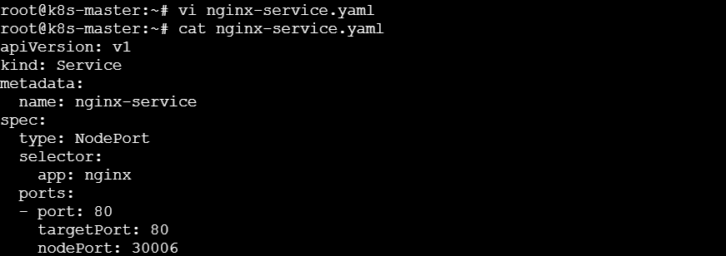
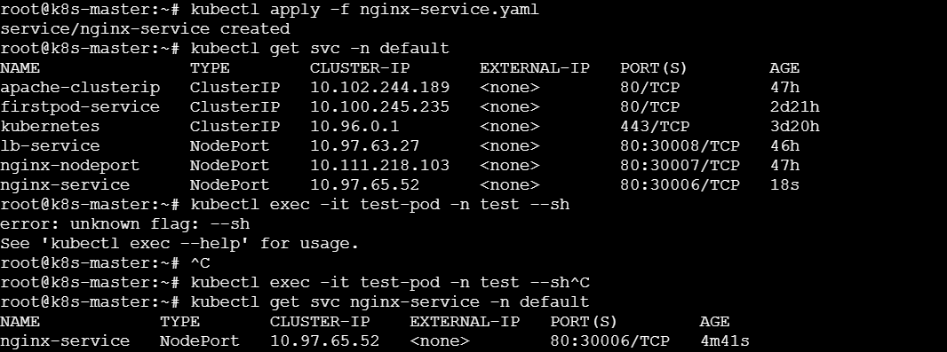
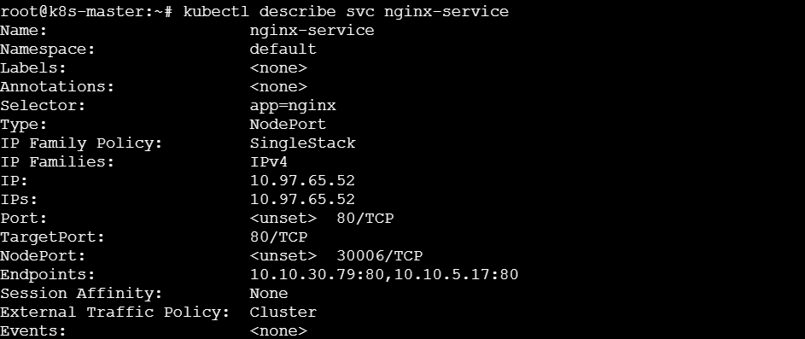
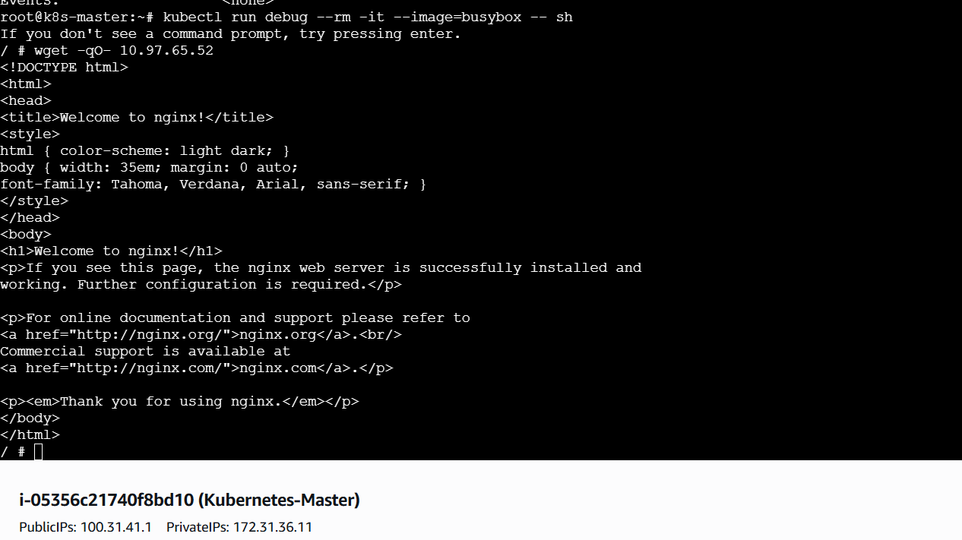

- Apply a LimitRange with a max limit/request ratio of 2 for memory in the performance-environment namespace, and test by creating a pod with mismatched resource requests and limits.

Steps Performed
Namespace Creation
• Created a new namespace named performance-environment
kubectl create namespace performance-environment
Namespace Verification
• Verified namespace creation
kubectl get namespaces
Observation:
• performance-environment → Status: Active
LimitRange YAML Creation
• Created LimitRange definition file
vi performance-limitrange.yaml
LimitRange Configuration
• Defined max limit/request ratio for memory
apiVersion: v1
kind: LimitRange
metadata:
name: performance-limits
namespace: performance-environment
spec:
limits:
- type: Container
maxLimitRequestRatio:
memory: "2"

LimitRange Deployment
• Applied LimitRange configuration
kubectl apply -f performance-limitrange.yaml
Result:
• LimitRange created successfully
LimitRange Verification
• Inspected applied LimitRange
kubectl describe limitrange performance-limits -n performance-environment
Confirmed:
• Max Limit/Request Ratio (Memory) → 2
Invalid Pod YAML Creation
• Created pod with mismatched memory request and limit
vi bad-pod.yaml
Configuration:
apiVersion: v1
kind: Pod
metadata:
name: bad-pod
namespace: performance-environment
spec:
containers:
- name: nginx
image: nginx
resources:
requests:
memory: "20Mi"
limits:
memory: "80Mi"
Invalid Pod Deployment Attempt
• Applied pod configuration
kubectl apply -f bad-pod.yaml
Result:
• Pod creation denied
Error:
pods "bad-pod" is forbidden: memory max limit to request ratio per Container is 2
Valid Pod YAML Creation
• Created pod adhering to ratio constraint
vi good-pod.yaml
Configuration:
apiVersion: v1
kind: Pod
metadata:
name: good-pod
namespace: performance-environment
spec:
containers:
- name: nginx
image: nginx
resources:
requests:
memory: "200Mi"
limits:
memory: "400Mi"
Valid Pod Deployment
• Applied corrected pod configuration
kubectl apply -f good-pod.yaml
Result:
• Pod created successfully
Pod Verification
• Verified pod status
kubectl get pods -n performance-environment
Observation:
• good-pod → Status: Running
Validation Steps
• Verified namespace creation
• Verified LimitRange creation
• Verified memory ratio constraint
• Verified Kubernetes blocked invalid pod
• Verified Kubernetes allowed valid pod
